電通四甲微處理器實驗 實驗結報

實驗名稱 | Lab 04—四合一七段顯示器
學號 | 05052421 | 組員 | 姚同宇

- 實驗目的
了解七段顯示器之顯示原理。
- 共陰極與共陽極七段顯示器之不同？
- 如何讓七段顯示器顯示0-F？
- 如何人控制四合一七段顯示器？
- 如何讓四合一七段顯示器顯示四位數字？
- 實驗步驟1
- Arduino接好四合一七段顯示器之電路
- 四合一七段顯示器每隔0.3秒鐘會跳一個數字，從0000→0059→0100跳至2359後歸零
- Check Point 1程式碼
#include "SevSeg.h"
SevSeg sevseg; //Instantiate a seven segment controller object
static unsigned long timer = millis();
static int Min = 0;
static int Hour = 0;
int button = 6;
boolean Pin6;
void setup() {
byte numDigits = 4;
byte digitPins[] = {4, 3, 2, 8};
byte segmentPins[] = {5, 9, 10, 11, 12, 13, 14, 15};
bool resistorsOnSegments = false; // 'false' means resistors are on digit pins
byte hardwareConfig = COMMON_CATHODE; // See README.md for options
bool updateWithDelays = false; // Default 'false' is Recommended
bool leadingZeros = false; // Use 'true' if you'd like to keep the leading zeros
bool disableDecPoint = false; // Use 'true' if your decimal point doesn't exist or isn't connected

sevseg.begin(hardwareConfig, numDigits, digitPins, segmentPins, resistorsOnSegments,
updateWithDelays, leadingZeros, disableDecPoint);
sevseg.setNumber(0000, 0);
sevseg.setBrightness(90);
}

void loop() {

if (millis() - timer >= 300) {
timer += 300;
Min++;
if(Min == 60) {
Min=0;
if(Hour == 24)
Hour=0;
else
Hour++;
}
sevseg.setNumber(Hour * 100 + Min, 0);
}
sevseg.refreshDisplay(); // Must run repeatedly
} delay(300);

- 實驗結果及分析1
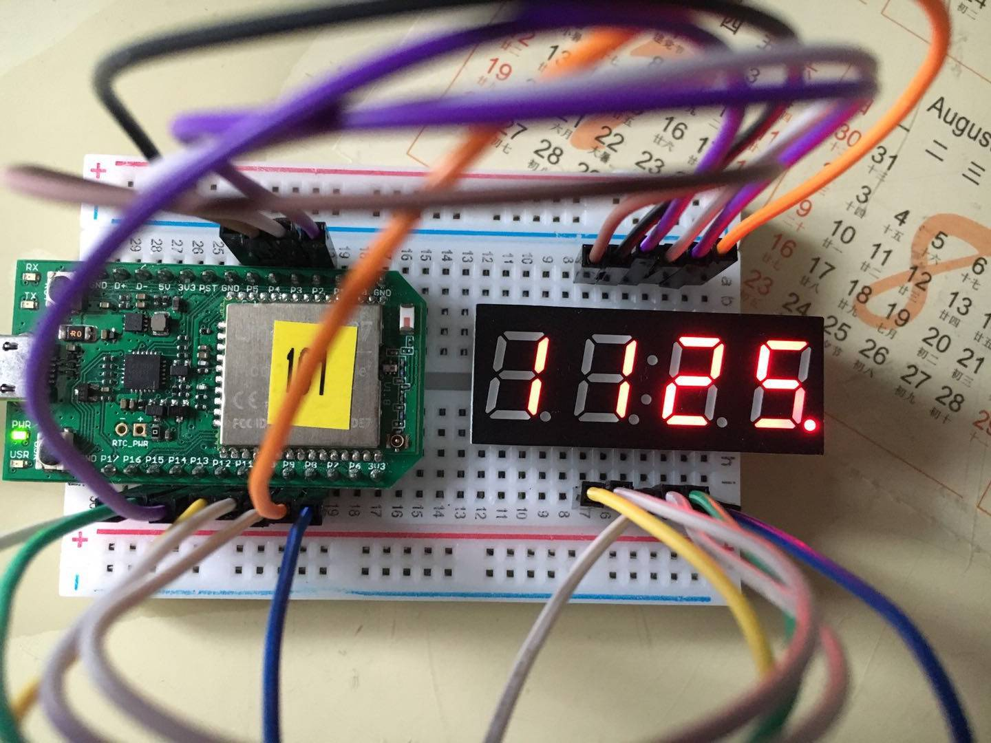
- 分析：四合一七段顯示器按照要求從0000→0059→0100跳至2359後歸零。
- 實驗步驟2
於Pin6按鍵，按下後歸零顯示
- Check Point 2 程式碼
#include "SevSeg.h"
SevSeg sevseg; //Instantiate a seven segment controller object
static unsigned long timer = millis();
static int Min = 0;
static int Hour = 0;
int button = 6;
boolean Pin6;
void setup() {
byte numDigits = 4;
byte digitPins[] = {4, 3, 2, 8};
byte segmentPins[] = {5, 9, 10, 11, 12, 13, 14, 15};
bool resistorsOnSegments = false; // 'false' means resistors are on digit pins
byte hardwareConfig = COMMON_CATHODE; // See README.md for options
bool updateWithDelays = false; // Default 'false' is Recommended
bool leadingZeros = false; // Use 'true' if you'd like to keep the leading zeros
bool disableDecPoint = false; // Use 'true' if your decimal point doesn't exist or isn't connected

sevseg.begin(hardwareConfig, numDigits, digitPins, segmentPins, resistorsOnSegments,
updateWithDelays, leadingZeros, disableDecPoint);
sevseg.setNumber(0000, 0);
sevseg.setBrightness(90);
}

void loop() {

Pin6 = digitalRead(button);
if (Pin6 == LOW) {
Min = Hour = 0;
}
if (millis() - timer >= 300) {
timer += 300;
Min++;
if(Min == 60) {
Min=0;
if(Hour == 24)
Hour=0;
else
Hour++;
}
sevseg.setNumber(Hour * 100 + Min, 0);
}
sevseg.refreshDisplay(); // Must run repeatedly
}
- 實驗結果及分析2
分析：按下USR按鍵後，七段顯示器數字顯示歸零。

